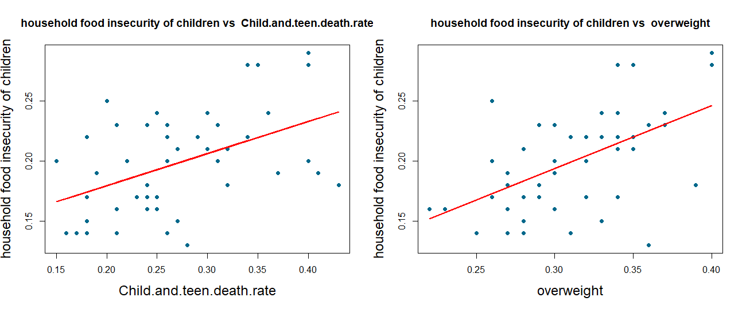

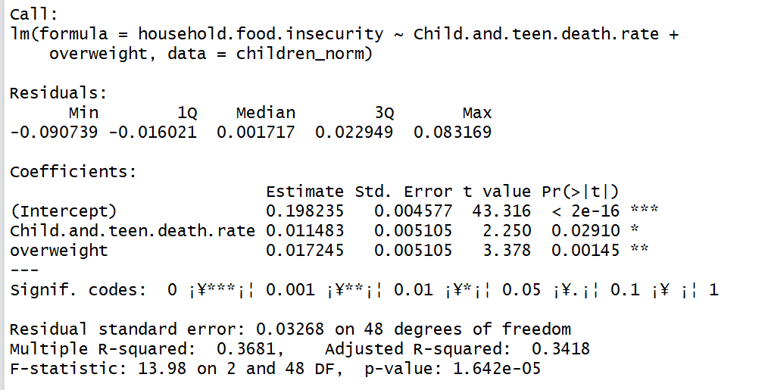

Call:

lm(formula = household.food.insecurity ~ Child.and.teen.death.rate +

overweight, data = children_norm)

Residuals:

Min 1Q Median 3Q Max

-0.090739 -0.016021 0.001717 0.022949 0.083169

Coefficients:

Estimate Std. Error t value Pr(>|t|)

(Intercept) 0.198235 0.004577 43.316 < 2e-16 ***

Child.and.teen.death.rate 0.011483 0.005105 2.250 0.02910 *

overweight 0.017245 0.005105 3.378 0.00145 **

---

Signif. codes: 0 ¡¥***¡¦ 0.001 ¡¥**¡¦ 0.01 ¡¥*¡¦ 0.05 ¡¥.¡¦ 0.1 ¡¥ ¡¦ 1

Residual standard error: 0.03268 on 48 degrees of freedom

Multiple R-squared: 0.3681, Adjusted R-squared: 0.3418

F-statistic: 13.98 on 2 and 48 DF, p-value: 1.642e-05